**Battle of Neighborhood Project Report**

# Introduction/ Business Problem

A popular chain restaurant in India wants to open their first international branch in USA in Manhattan, New York City. They have the initial funding but needs investors in USA to fund their project to completion. A part of the business investment report, they would like to show the area or neighborhood in where they can open their restaurant to get the maximum return on investment in span for first three years. Hence, they need help in identifying the neighborhood where they can start their first restaurant in Manhattan.

# Data

We will use New York city neighborhood data to get all the neighborhoods within Manhattan borough. We will then use Foursquare location data APIs to explore each Manhattan neighborhood and identify the frequency of the Indian Restaurants in each of them. Neighborhoods with no Indian restaurants will be the best candidate for investment.

## NYC Neighborhood Data

We collected the New York City data which contained 5 boroughs and more than 36 neighborhoods. As we wanted to get the location of each of the neighborhood, we ran a geolocator function to get the latitude and longitude of each neighborhood in the New York City and created one pandas dataframe and created map to see all neighborhoods across the city.

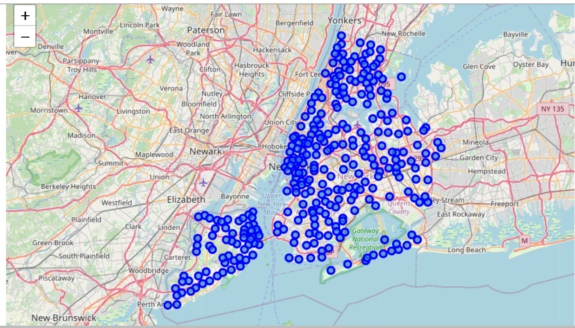

After creating the dataframe, we wanted to focus on only Manhattan as the client wanted to open restarurant in Manhattan. So, we filtered the data to have only Manhattan neighborhoods and their coordinates. We then developed a map with Manhattan neighborhoods marked on it.

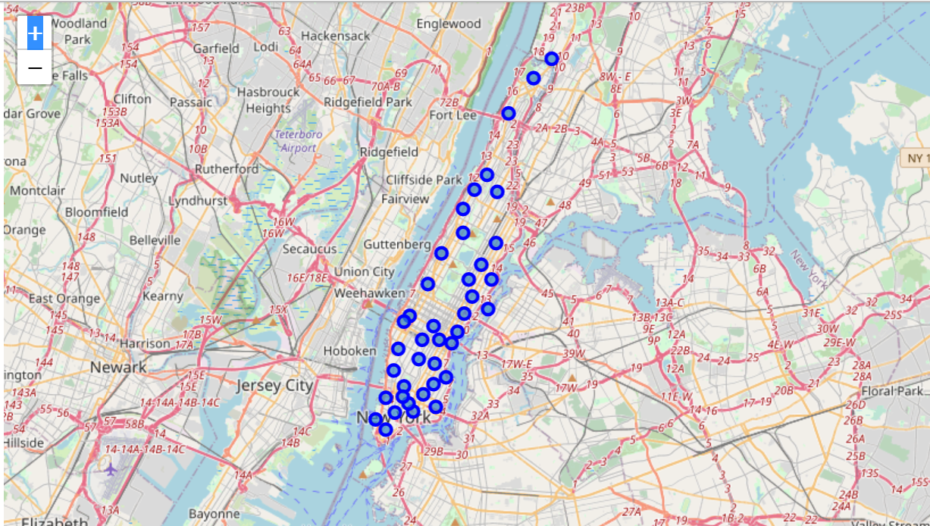

## Foursquare Data

With the help of Foursquare APIs we then fetched all the venues from the Manhattan neighborhood through Explore API

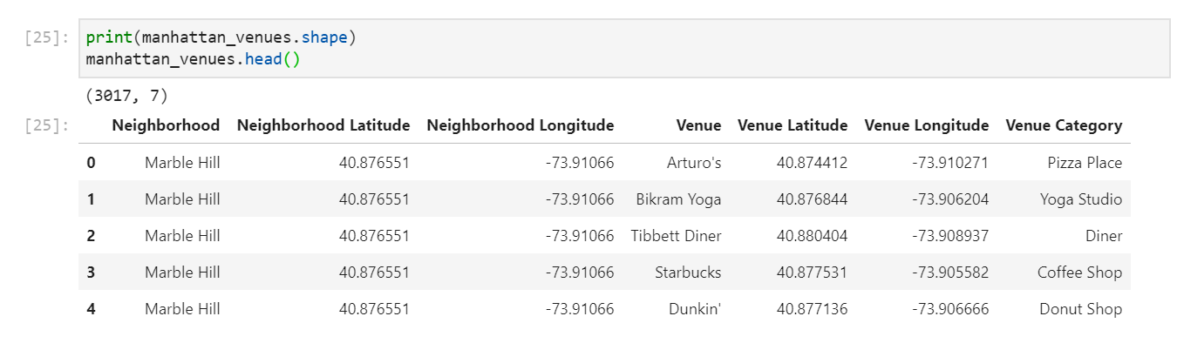

Also, checking how many venues were returned from each neighborhood:

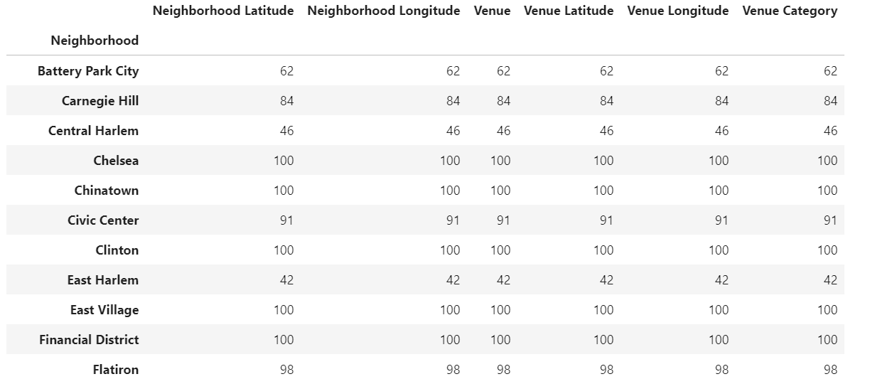

And with the help of these data, identified that there were 329 unique categories of the venues available in Manhattan neighborhoods.

# Methodology

## Analyzing Neighborhoods

With that approach we started analyzing each neighborhood with frequency of most common venues under each of them:

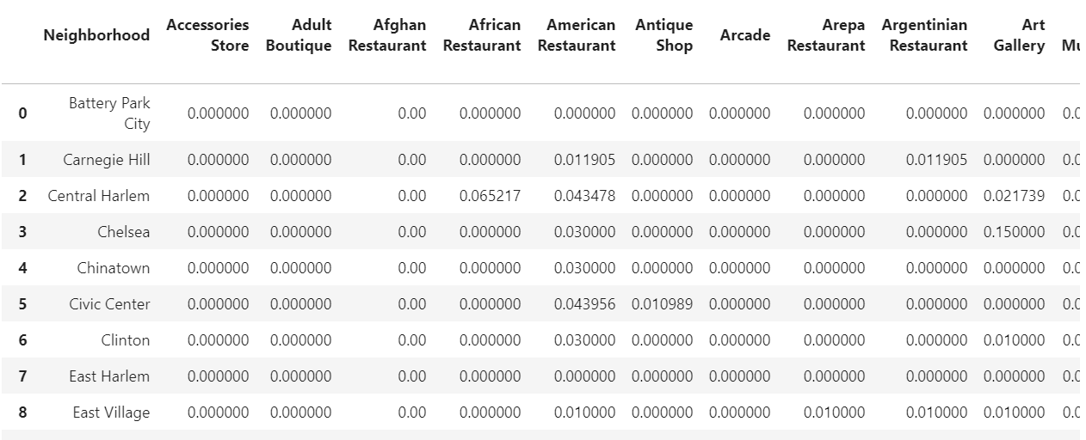

We confirmed that there were 330 different venues within 40 Manhattan neighborhoods with some frequency of appearance in the data.

From this dataset, we removed the neighborhoods which had any Indian restaurants in them. We found out that there were 16 neighborhoods with Indian restaurants in them and 24 neighborhoods without them.

Out of the 24 neighborhoods, we wanted to identify the top 5 common venues for each of them:

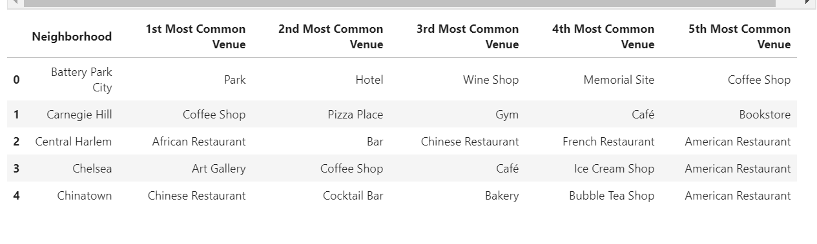

## Clustering

We then clustered these neighborhoods in 5 clusters so that we can understand the grouping of most common venues within each cluster. We also removed neighborhoods with any restaurants in ‘1st most common venue’. We found out that there 15 neighborhoods with no restaurants in ‘1st most common venue’ grouping.

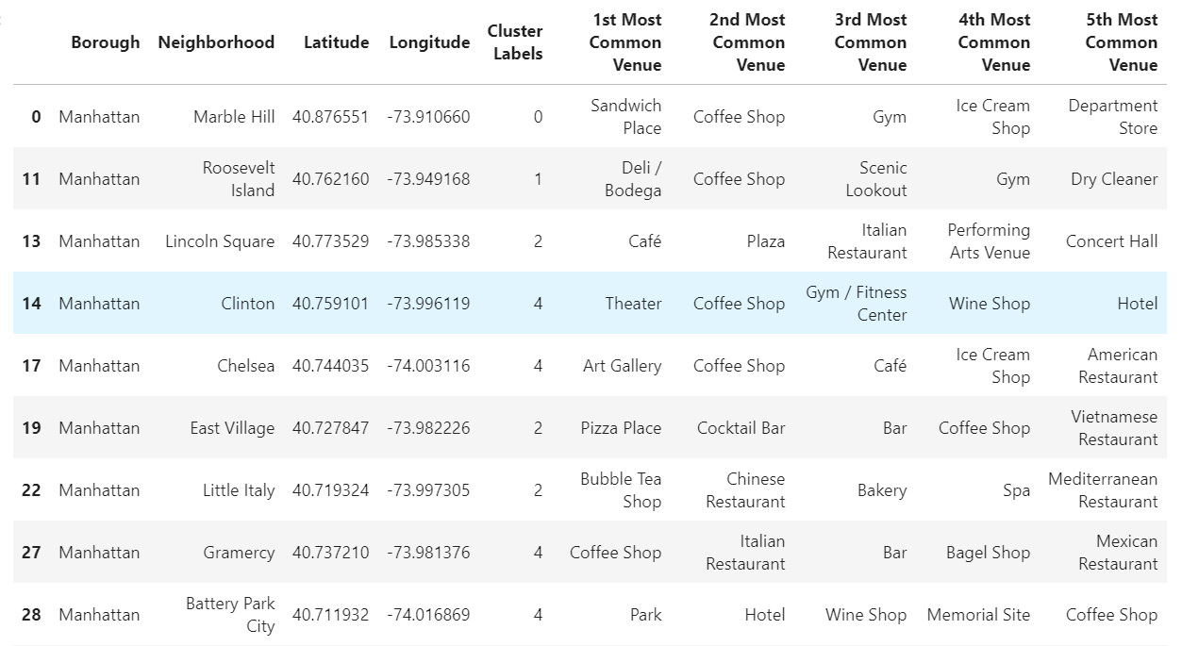

We then mapped all 5 clusters on the Manhattan map and identified the clusters with no restaurants:

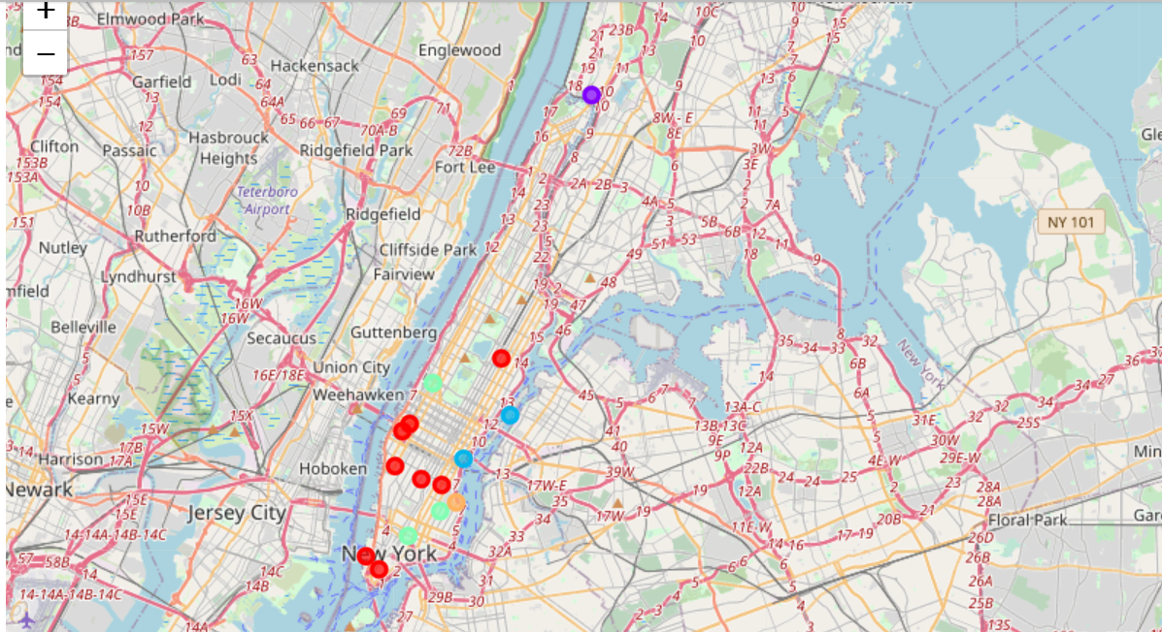

# Results

After the analysis we found out there are two clusters with no restaurants in them, that is there are two Manhattan neighborhoods with no restaurants in them:

### Cluster 1 – No Restaurants

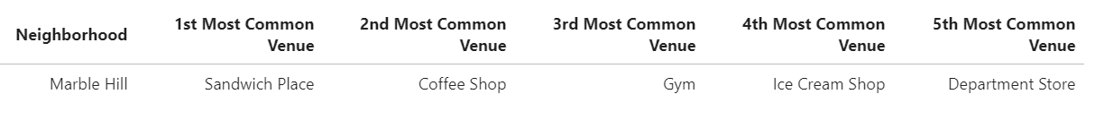

### Cluster 2 – Less than 2 restaurants

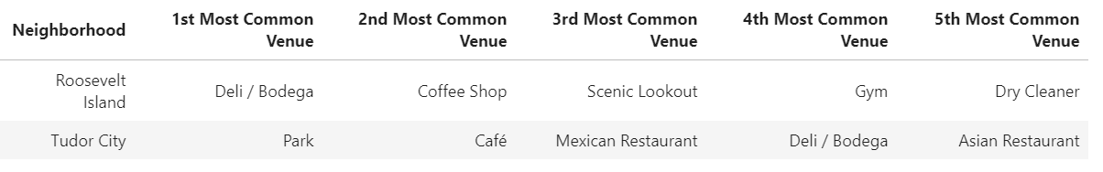

### Cluster 3 – More than 2 restaurants

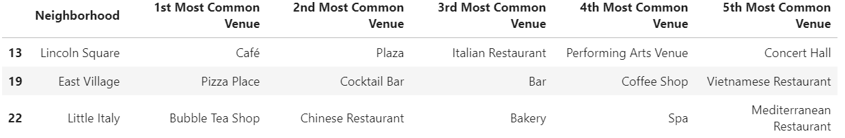

### Cluster 4 – No restaurants

### 

### Cluster 5 – More than 5 restaurants

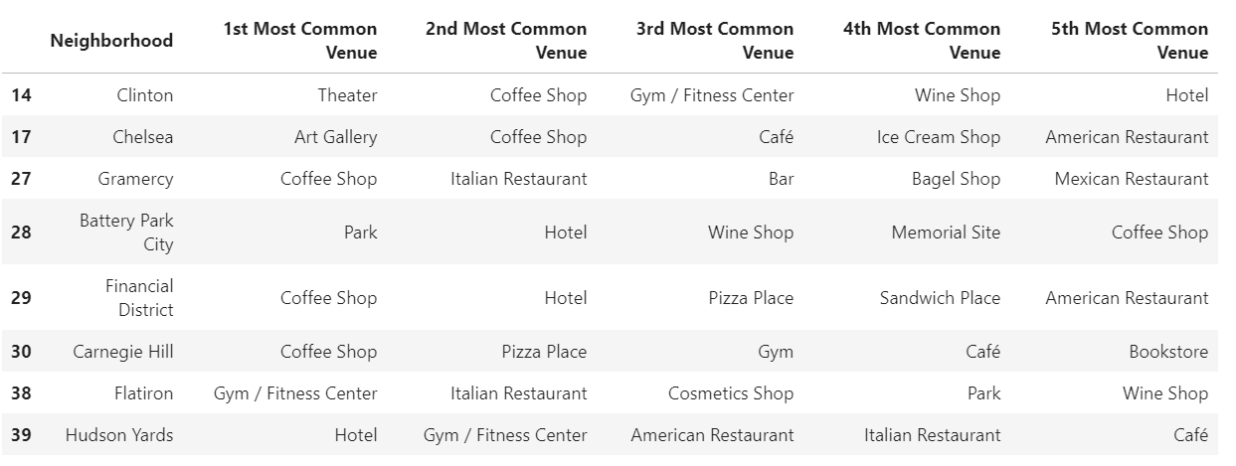

# Observations:

Based on our analysis we found out that out of 40 neighborhoods in Manhattan, 24 neighborhoods didn’t have any Indian restaurants in them, and out of 24, there are 15 neighborhoods without any restaurant with high frequency. So, based on the analysis there is one neighborhood in upper Manhattan and one in downtown which are the good candidates.

# Conclusion:

We are concluding that Stuyvesant Town and Marble Hill are the two most recommended neighborhoods in Manhattan to open an Indian restaurant.